FOR IMMEDIATE RELEASE

Date: 6/13/2017
Press Contact: Lauren Lorenzo
Phone: 800-526-0242 x1025
Fax: 201-814-0510
Email: marketing@comprehensiveco.com

Comprehensive Introduces New 4K Certified 18G Commercial HDMI Cables for Systems Integration Up to 50ft
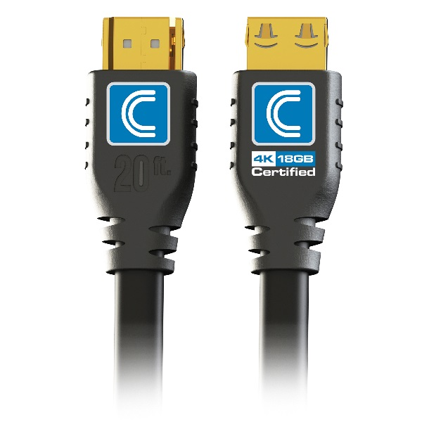
Fairfield, NJ – Comprehensive Connectivity Company, the tested and trusted connectivity solutions manufacturer to the Pro AV/IT markets for more than 40 years, launches their new Pro AV/IT HD18G series of 4K 18G HDMI Cables (HD18G-xxPROBLK) for System Integration and other demanding commercial environments.

Comprehensive’s Pro AV/IT Certified 18Gbps 4K (End to End) HDMI cables are unlike any other cable on the market today as they were created specifically for the demanding needs of systems integration and commercial applications. HD18G series cables feature heavy duty, all commercial construction, Comprehensive’s exclusive ProGrip® connector, and SureLength® indicators right on the connector head.

Comprehensive Pro AV/IT Certified 18Gbps 4K (End to End) HDMI cables have full 18G performance and come equipped with all the latest HDMI features including Ultra HD 4K@60Hz 4:4:4 chroma sampling, transmission of High Dynamic Range (HDR) video, up to 32 audio channels with ARC, and support for wide angle theatrical 21:9 aspect ratio support giving you the full 4K experience as it was meant to be. Longer lengths utilize state-of-the-art active chip technology to deliver a full 4K 18Gb signal with 4:4:4 Color Space signal.

Comprehensive's exclusive ProGrip® connector helps secure the connection with up to 16lbs of retention force to prevent cables from being unintentionally disconnected. Other exclusive features are Comprehensive's SureLength® cable length indicators that clearly indicate the length of each cable on the connector mold - huge time savers for installers who are constantly sorting out lengths preparing for jobs!

A re-enforced molded strain relief provides unsurpassed durability and Lifetime Warranty ensures endless years of worry-free use. Comprehensive’s flexible matte jacket with UL/CL3 ratings makes this cable perfect for any commercial or residential installation as well as other demanding environments.

Features and Benefits

- Certified 18Gbps High Speed, Ultra HD 4K@60 4:4:4 (End to End)-All lengths
- Enables transmission of High Dynamic Range (HDR) Video
- Exclusive ProGrip® connector utilizes up to 16 lbs of retention force to help keep connector in place
- SureLength® cable length indicators on the connector heads make it easy to organize for installations
- True Professional / Commercial grade Heavy Duty construction
- Lengths up to 50ft
- UL Type CL3 rating / RoHS Certified
- Ethernet & CEC Capability
- Supports SA-CD, DVD-Audio, DTS-HD Master Audio™, Dolby TrueHD™, and other high-definition audio standards
- Lifetime Warranty

Sku’s include HD18G-3PROBLK, HD18G-6PROBLK, HD18G-9PROBLK, HD18G-12PROBLK, HD18G-15PROBLK, HD18G-20PROBLK, HD18G-25PROBLKA, HD18G-35PROBLKA and HD18G-50PROBLKA.

Product Image: https://www.comprehensiveco.com/resize/shared/images/products/comprehensive/hd18g.jpg

For more information about Comprehensive or any Comprehensive products, please visit us at www.ComprehensiveCo.com, call toll free at 800-526-0242 or email sales@comprehensiveco.com

ensivecable.com
About Comprehensive Connectivity
Since 1974, Comprehensive Connectivity has been the Pro AV and IT industry standard for professional connectivity performance, reliability and value. That’s why millions of Comprehensive connectivity products are in use at stadiums, in broadcast and recording studios, stages, boardrooms, classrooms, government installations and living rooms around the world. Comprehensive Connectivity Company is a division of New Jersey based VCOM International Multimedia Corporation.

